## Skill-React

React Hands-on Lab: My First React App

# Code:

## Terminal Instructions:

**# 1. Install create-react-app**

**npm install -g create-react-app**

**# 2. Create a new React application named "myfirstreact"**

**npx create-react-app myfirstreact**

**# 3. Move into the project directory**

**cd myfirstreact**

**# 4. Open the project in Visual Studio Code**

**code .**

**# 5. Start the React development server**

**npm start**

## Code(App.js):

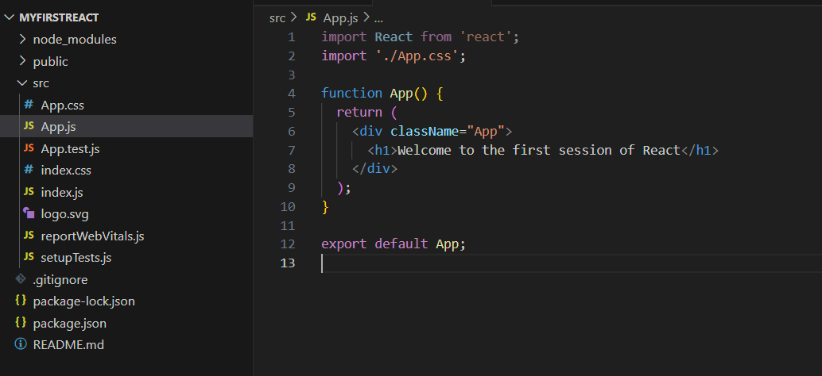

# Output:

